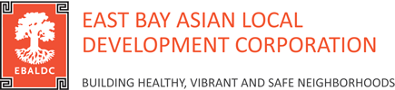
DECLARATION OF LEGACY GIFT SUPPORT FORM
Thank you for your commitment to EBALDC and its mission! Please help us ensure we will be able to carry out your intentions by completing and returning this form.
DONOR INFORMATION
Name: _________________________________________________________
Address: _________________________________________________________
Phone #: _________________________________________________________
Email: _________________________________________________________
GIFT INFORMATION
We plan to make a gift to EBALDC through my/our:

- Will(s)
- Living trust(s)
- Retirement Plan(s)
- Life Insurance Policy
- Charitable trust
- Other

If your gift is through a retirement plan or life insurance policy, the following information is very important to help us actually receive what you intend to give.
Name of company/plan administrator:
___________________________________________________________________________
Contact information: _________________________________________________________
Policy number: _________________________________________________________
Additionally, a copy of your “designation of beneficiary form” you sent to your plan administrator would be extremely helpful.
As of this date, the estimated value of my/our gift is: $__________
This is especially important if your gift is designated for a specific purpose.
GIFT ACKNOWLEDGMENT
Please acknowledge my/our legacy commitment as follows:
Signature: _________________________________________________________
Printed name: _________________________________________________________

