Affordable Housing

Opening June 2025

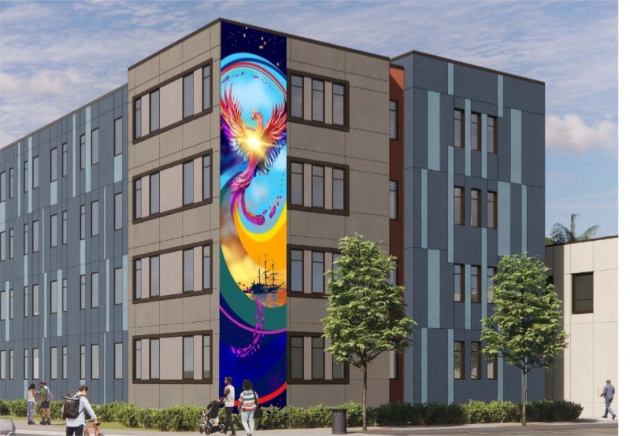

Phoenix Apartments (the “Project”) is a 101-unit apartment building, located at 811 and 821 Pine Street Oakland CA 94611. The Project is an affordable permanent rental housing community for extremely low-income to low-income.

**Referral units:**

Fifty (50) units will be restricted as Permanent Supportive Housing (PSH) to persons experiencing or at risk of homelessness with special needs. Forty-nine (49) of these units are restricted to households with incomes at or below 30% AMI and one (1) unit is restricted to households at or below 50% AMI. Unit types available to PSH households include 41 studios, 1 one-bedroom and 7 two-bedrooms; All referrals for occupancy to those forty-nine (49) Permanent Supportive Housing (PHS) Units will be made through the Alameda County Health homeless Coordinated Entry System pursuant to the Implementation Policies (the "CES Units").

If you are matched to Phoenix, please submit materials to **HomeStretch@acgov.org**.

Eligibility is income-restricted in accordance with the Low-Income Housing Tax Credit program, as well as other funding program requirements.

|  |  |  |  |  |  |
| --- | --- | --- | --- | --- | --- |
| Size | Minimum Income |  | # of HH members | 30% (49 units) | 50% (1 Unit) |
| 0 BDRM | **$11,685** |  | 1 person | **$32,700** | **$54,500** |
| 1 BDRM | **$12,514** |  | 2 persons | **$37,380** | **$62,300** |
| 2 BDRM | **$15,028** |  | 3 persons | **$42,060** | **$70,100** |

|  |  |  |  |  |  |  |
| --- | --- | --- | --- | --- | --- | --- |
|  | | |  | With Significant Other | | |
| Size | Min | Max |  | Size | Min | Max |
| 0 | 1 | 1 |  | 0 | 2 | 2 |
| 1 | 1 | 1 |  | 1 | 2 | 2 |
| 2 | 2 | 3 |  | 2 | 3 | 4 |
| 3 | 4 | 5 |  | 3 | 5 | 6 |

|  |
| --- |
| **AMENITIES**  Near Bertha Port Park, Serda Corps Memorial Sanctuary, West Oakland Bart, Prescott Circus Theater, Prescott Elementary, this is a smoke-free community |

**Rents**

|  |  |  |  |
| --- | --- | --- | --- |
|  | **0 BDRM** | **1 BDRM** | **2 BDRM** |
| **15%** | **$409** | **$438** | **$526** |

Maximum Income



Occupancy Standards