Affordable Housing - Waiting list opening

OPen to general public

Now accepting pre-applications for Studio, 1-, 2-bedroom units.

Opens March 28th at 9:00 AM and closes on April 17th at 5:00 PM

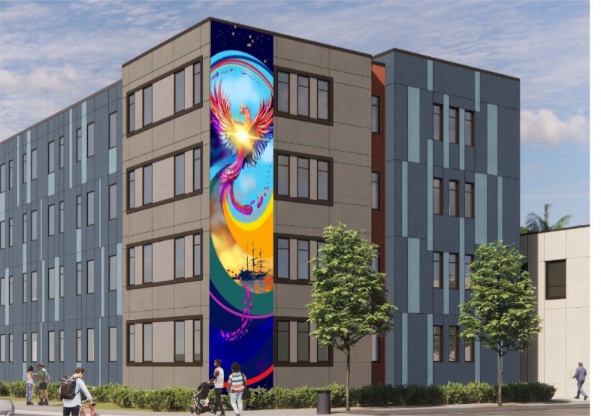

Phoenix Apartments (the “Project”) is a 101-unit apartment building, located at 811 and 821 Pine Street Oakland CA 94611. The Project is an affordable permanent rental housing community for extremely low-income to low-income.

Fifty (50) units will be non-referral units in which applicants are not referred through CES. Applications will be selected from a waiting list that will be initially established through a lottery.

Applications to be considered for the lottery can be completed on the EBALDC housing portal at <http://EBALDC.org>. Applications who are unable to access and complete the application through the online portal may our leasing office at 510-306-1621 to request a reasonable accommodation or modification during the published period of the open waiting lottery period.

Pre-applications to be considered for the lottery can be completed on EBALDC housing portal at [http://ebaldcphoenix.com](http://ebaldc.org). Applicants who are unable to access and complete the pre-application through the online portal may call our leasing office at 510-306-1621 to request a reasonable accommodation or modification during the published period of the open waiting lottery period. Paper pre-applications will be available online to print. Paper pre-applications must be mailed to 1825 San Pablo Ave #200 Oakland CA 94106 Attn: Phoenix. Paper pre-applications will be available to pick up at 1825 San Pablo Ave #200 Oakland at these times: Tuesday, April 8, 2025 from 10 am to Noon and Wednesday, April 9th, 2025 from 1pm to 3pm. Paper pre-applications must be mailed to 1825 San Pablo Ave #200 Oakland. Pre-applications must be received by deadline.

Applicable languages: Spanish, Chinese

|  |  |  |  |  |  |  |
| --- | --- | --- | --- | --- | --- | --- |
| No Significant Other | | |  | With Significant Other | | |
| Size | Min | Max |  | Size | Min | Max |
| 0 | 1 | 1 |  | 0 | 2 | 2 |
| 1 | 1 | 1 |  | 1 | 2 | 2 |
| 2 | 2 | 3 |  | 2 | 3 | 4 |
| 3 | 4 | 5 |  | 3 | 5 | 6 |

**Rents**

The maximum rents listed in the table below are **net rents**, calculated after deducting the applicable **utility allowance published by the Oakland Housing Authority**.

|  |  |  |  |
| --- | --- | --- | --- |
|  | **0 BDRM** | **1 BDRM** | **2 BDRM** |
| **50%** | **$1,288** | **$1,371** | **$1,624** |

**Minimum Income**

**Maximum income**

|  |  |  |  |  |
| --- | --- | --- | --- | --- |
|  | **50%** |  |  | **50%** |
| **1 Persons** | **$54,500** |  | **0 BDRM** | **$36,800** |
| **2 Persons** | **$62,300** |  | **1 BDRM** | **$39,171** |
| **3 Persons** | **$70,100** |  | **2 BDRM** | **$46,400** |
| **4 Persons** | **$77,850** |  |  |  |

|  |
| --- |
| **AMENITIES**  Near Bertha Port Park, Serda Corps Memorial Sanctuary, West Oakland Bart, Prescott Circus Theater, Prescott Elementary, this is a smoke-free community |



**Occupancy Standards**