A RentCafe Applicant Registration Guide is a resource designed to help prospective renters successfully create an account and apply for a rental property through the EBALDC RentCafe platform.

RentCafe is an online property management leasing system used by EBALDC to manage listings and applications, leases, and resident services. For applicants, the registration process is the first step toward securing a home.

Please follow this guide to help you create, access, and manage your account as well as start a waiting list application:

- Applicants must register as a RENTCafé user to apply online for EBALDC housing.
- A valid email address is required to register.
- The RENTCafé Online Application portal can be accessed by any computer, smartphone, or tablet
through its internet browser.
- If you do not have internet access or an internet- enabled device, please see the Resource List of Public Computer Locations on our website.

Go to: EBALDC.ORG. Scroll down and click the property’s application link to create an account or register an existing RENTCafé account.

This guide will cover:
- Creating Your account (First time users)
- Invalid Account Error (Returning users)
- Password Reset
- Starting the Waiting list Application
- Managing your account

- Creating Your Account (First time users)
Please follow the steps below to apply online for EBALDC housing. Even if you already have an existing RENTCafé account, you will need to register for EBALDC’s specific property.

If you need assistance with registration, please call the number on the flyer.
  - To begin, click the “Click here to register” link in the left login box, or click Register Now under
    - Click “I do NOT have a registration code”

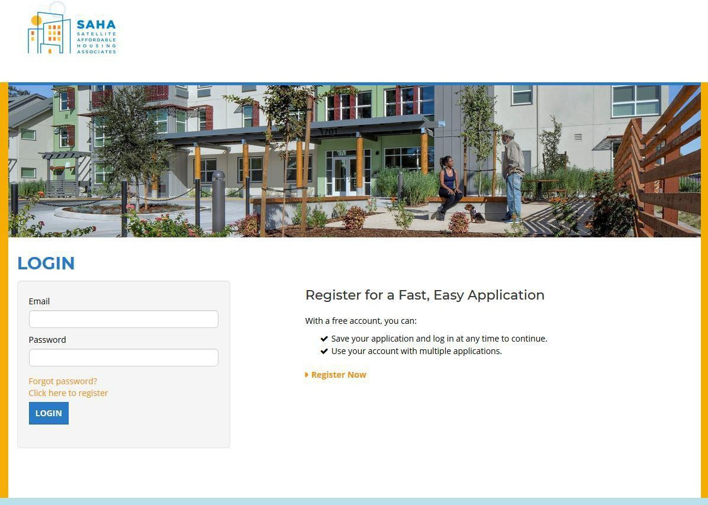

Click on “I do Not have a registration code”
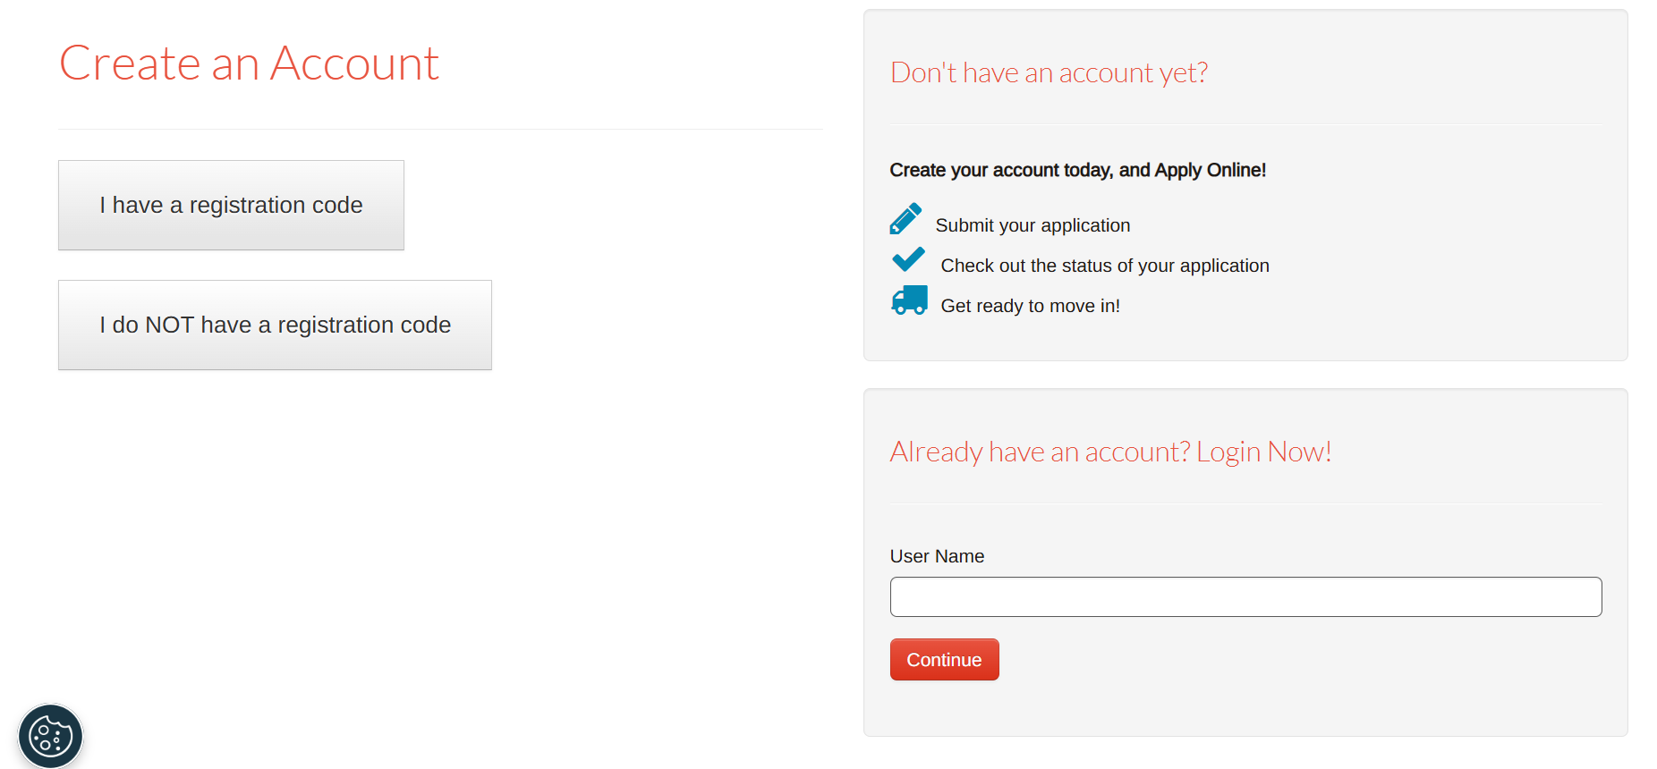
You will then be directed to create an account screen, complete

  - Enter your information under the Personal Details and Account Information sections. Required fields are denoted by an asterisk (*).

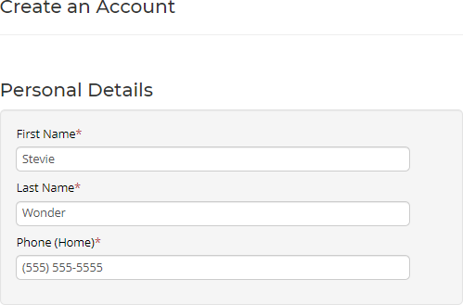

Log in using /completing account information

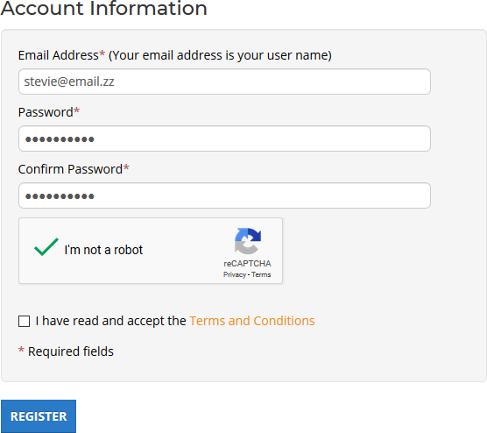

Please note:
- Your email address is your username
- Your password must be a minimum of 10 characters and must contain all of the following:
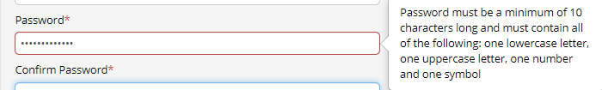
  - One lowercase letter
  - One uppercase letter
  - One number
  - One symbol

- If you have an existing RENTCafé account, a pop-up will prompt you to use your existing account. Click the “Use My Existing Account!” button to log in under your existing account.
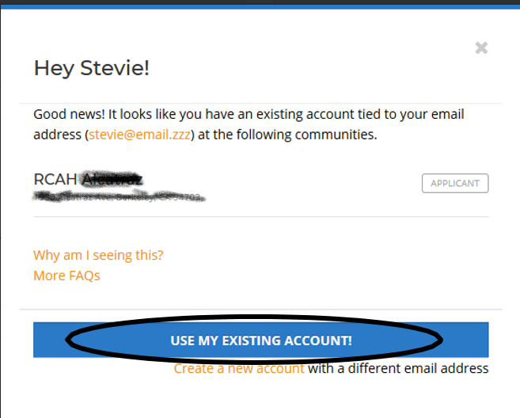

Note: Returning users should click “my existing account” and refresh the community listings to apply. If the listing DOES NOT auto populate, prospect may provide alternate emails to complete registrations.

- INVALID ACCOUNT ERROR

**If you encounter an “Invalid account” error, click on “Register Now” to return to step #2.
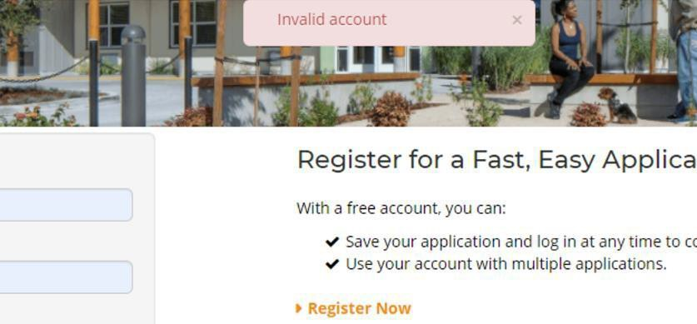

- Once the fields are completed, click the “I’m not a robot” reCAPTCHA. Check that you have read and accept the Terms and Conditions and then click Accept to continue.
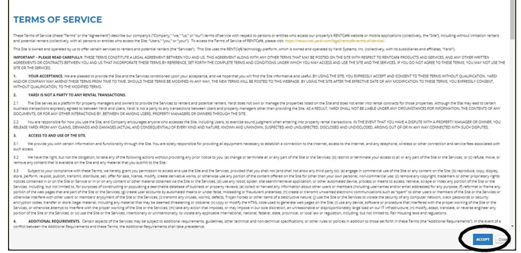
- Click the “Register” button to register the account.

After registering, you will receive the “User Registration Confirmation” email from RENTCafé.
From: EAST BAY ASIAN LOCAL DEVELOPMENT <NO-REPLY@RENTCAFE.COM
SUBJECT: USER REGISTRATION CONFIRMATION

- PASSWORD RESET

If you forgot your password, click on “I forgot my password” to receive an email with instructions and a password reset link.

After changing your password, you will be taken back to the log in screen

Once in the log in screen, enter your email address to trigger the pop-up prompting you to use your existing account.

Click the “Use my Existing Account” button to log in under your existing account with your newly created password.

- Starting the Waitlist Application

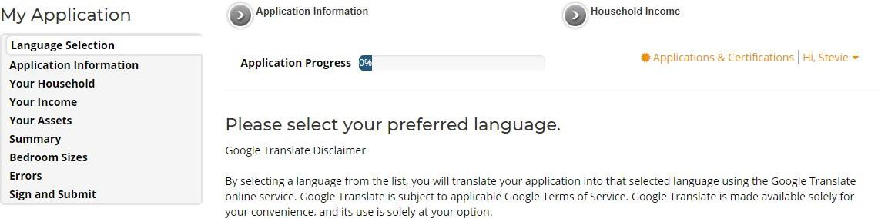
If the property’s waitlist is open and accepting applications, the page will redirect to the start of the waitlist application.

***If the property’s waitlist is closed and not currently accepting applications, you will see the following screen:
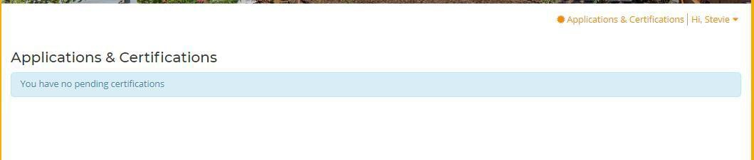

Once you begin the waitlist application, you will receive the “Waitlist Application Started” email from RENTCafé.
From: EAST BAY ASIAN LOCAL DEVELOPMENT <NO-REPLY@RENTCAFE.COM
SUBJECT: Rent Café-Waitlist Application Started

As long as the waitlist is open, you also have the option to save the application at any point and continue it at a later time. To continue the waitlist application, click the “Continue” button to start where you last left off.
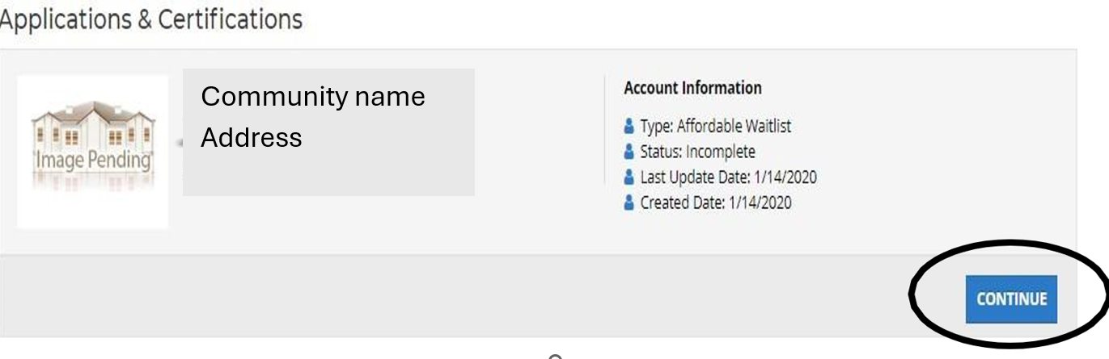

As long as the waitlist is open, if you have completed the waitlist application, you can review your information by clicking the “View” button.

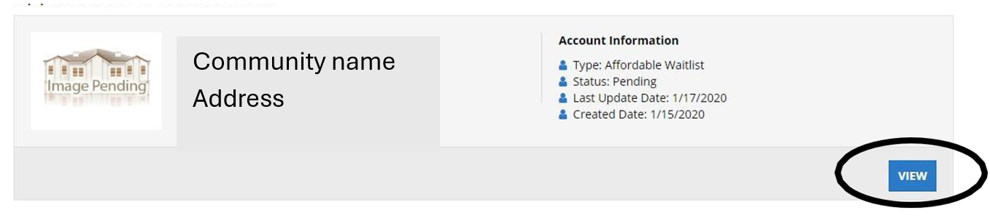
***Once the waitlist is closed, you will be unable to view or submit your waitlist application. E. Managing Your Account
- On the top right, click the “Hi, [Name]” link and click My Profile to change account information including phone and email information.
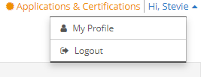
- Click Update Account to make changes to your account information.

- Note that changing your account information will update all of the in-progress applications.

- Uncheck the box to unsubscribe from RENTCafé email notifications, otherwise leave the box checked to receive email notifications.

- Note that these email notifications refer to general updates from RENTCafé. Important system notification emails related to your application or account cannot be turned off.
